SCHOOL OF COMPUTER SCIENCE AND ARTIFICIAL INTELLIGENCE |  |  |  |  | DEPARTMENT OF COMPUTER SCIENCE ENGINEERING
Program Name: B. Tech |  |  |  | Assignment Type: Lab |  | Academic Year:2025-2026
CourseCode |  |  | 23CS002PC304 | Course Title |  |  | AI Assisted Coding
Year/Sem |  |  | III/II | Regulation |  |  | R23
Date and Day  of Assignment |  |  | Week2 – Monday | Batch |  |  | 23CSBTB48
Name |  |  | Bachu Tejaswini | Hall Ticket No |  |  | 2303A54057
Assignment Number: 4.1(Present assignment number)/24(Total number of assignments)
 | Q.No. | Question
 | 1 | Lab 4: Advanced Prompt Engineering – Zero-shot, One-shot, and Few-shot Techniques  Lab Objectives:  - To explore and apply different levels of prompt examples in AI-assisted code generation.  - To understand how zero-shot, one-shot, and few-shot prompting affect AI output quality.  - To evaluate the impact of context richness and example quantity on AI performance.  Lab Outcomes (LOs):  After completing this lab, students will be able to:  - Use zero-shot prompting to instruct AI with minimal context.  - Use one-shot prompting with a single example to guide AI code generation.  - Apply few-shot prompting using multiple examples to improve AI responses.  - Compare AI outputs across the three prompting strategies.  Analyze the sample example problem and complete the given problem statement 1,2  Advanced Prompt Engineering – Topic Classification of News Headlines  Sample Example Problem:  Problem Statement 0:  A news aggregation platform wants to automatically categorize headlines into Politics, Sports, Technology, and Entertainment without training a machine learning model.  Tasks to be Completed  - Prepare Sample Data  Collect 10 news headlines, each belonging to one of the four categories.  - Zero-shot Prompting  Write a prompt asking the LLM to classify a headline into a category without examples.  - One-shot Prompting  Add one labeled headline example before classifying a new headline.  - Few-shot Prompting  Use 3–5 labeled headlines in the prompt before requesting classification.  - Evaluation  Compare outputs from all three prompting methods using the same test headlines and document observation  Sample Solution for problem statement 0:  1. Sample News Headlines  2. Zero-shot Prompting  Prompt Used:  Classify the following news headline into one of these categories: Politics, Sports, Technology, Entertainment.  Headline: “India wins the T20 cricket series.”  Output:  Sports  Observation:  The model correctly classified the headline without using any example.  3. One-shot Prompting  Prompt Used:  Example:  Headline: “Government announces new education policy”  Category: Politics  Now classify the following headline into Politics, Sports, Technology, or Entertainment.  Headline: “Tech company launches a new AI-powered smartphone.”  Output:  Technology  Observation:  Providing one example improved clarity and consistency in classification.  4. Few-shot Prompting  Prompt Used:  Example 1:  Headline: “Parliament passes new tax reform bill”  Category: Politics  Example 2:  Headline: “Football club signs a new international player”  Category: Sports  Example 3:  Headline: “Cybersecurity firm reports major data breach”  Category: Technology  Example 4:  Headline: “Upcoming movie breaks box office records”  Category: Entertainment  Now classify the following headline into Politics, Sports, Technology, or Entertainment.  Headline: “Popular actor announces next film project.”  Output:  Entertainment  Observation:  Few-shot prompting produced the most accurate and confident response
  No. | News Headline | Category
  H1 | Government announces new education policy | Politics
  H2 | Parliament passes new tax reform bill | Politics
  H3 | India wins the T20 cricket series | Sports
  H4 | Football club signs a new international player | Sports
  H5 | Tech company launches a new AI-powered smartphone | Technology
  H6 | Cybersecurity firm reports major data breach | Technology
  H7 | Upcoming movie breaks box office records | Entertainment
  H8 | Popular actor announces next film project | Entertainment
 | Problem Statement1 | Customer Email Classification  A company receives a large number of customer emails every day and wants to automatically classify them into the following categories:  - Billing  - Technical Support  - Feedback  - Others  Instead of training a new machine learning model, the company decides to use prompt engineering techniques with an existing large language model.  Tasks  - Prepare five short sample emails, each belonging to one of the above categories.  Sample Emails  - Billing: "My latest invoice #1234 shows $50 overcharge. Please refund or explain."  - Technical Support: "App crashes on login with error 500. Running iOS 17. Steps to fix?"  - Feedback: "Love the new UI but search is slow. Great product overall!"  - Others: "When's Black Friday sale? Any promo codes?"  - Billing (extra): "Failed payment alert. Update my card on file."  - Write a zero-shot prompt to classify a given email into one of the categories without providing any examples.  Prompt:  Classify this customer email into one category only: Billing, Technical Support, Feedback, or Others.  Email: "Server down again. Need urgent help."  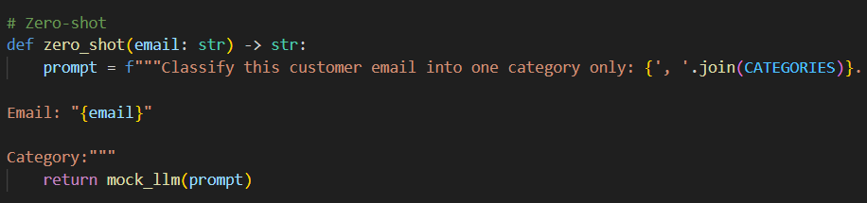  - Write a one-shot prompt by including one labeled email example and ask the model to classify a new email.  Prompt:  Example:  Email: "My latest invoice #1234 shows $50 overcharge. Please refund."  Category: Billing  Classify this email:  Email: "Server down again. Need urgent help."  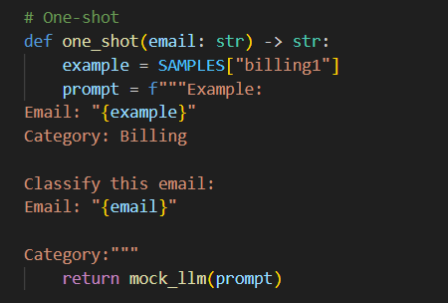  - Write a few-shot prompt by including two or three labeled email examples and ask the model to classify a new email.  Prompt:  Examples:  Email: "My latest invoice #1234 shows $50 overcharge. Please refund."  Category: Billing  Email: "App crashes on login with error 500. Running iOS 17."  Category: Technical Support  Email: "Love the new UI but search is slow. Great product!"  Category: Feedback  Classify this email:  Email: "When's Black Friday sale? Any promo codes?"  Category:  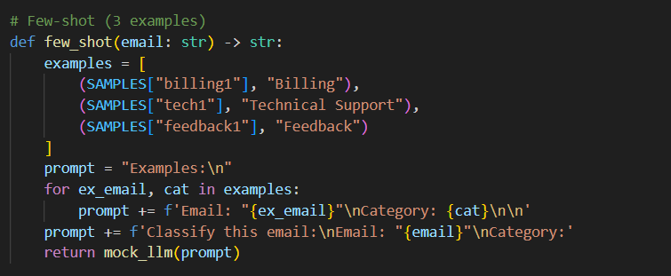  - Compare the outputs obtained using zero-shot, one-shot, and few-shot prompting techniques and briefly comment on their effectiveness  Explanation:  AI wrote bad login:  - Password "secret123" written directly in code  - Anyone reading code knows password  - No limit on wrong tries  I fixed it:  - Password becomes unreadable code (hash)  - Hide password when typing (stars show)  - Only 3 tries allowed  Like: Lock with secret combo written on door → I hid combo + added 3-try limit
  Technique | Test Email: "Subscription renewed but no confirmation email" | Why It Works/Fails
  Zero-Shot | Billing | Keyword matching (renewed= billing trigger)
  One-Shot | Billing | Billing example reinforces money theme
  Few-Shot | Billing | Multiple anchors prevent overgeneralization
 | Problem Statement 2 | Intent Classification for Chatbot Queries  A company wants to deploy a chatbot to handle customer queries. Each query must be classified into one of the following intents: Account Issue, Order Status, Product Inquiry, or General Question using prompt engineering techniques.  Tasks to be Completed  - Prepare Sample Data  - Zero-shot Prompting  Design a prompt that asks the LLM to classify a user query into the given intent categories without examples.  Prompt:  Classify this chatbot query into one intent: Account Issue, Order Status, Product Inquiry, General Question.  Query: "My password reset link expired"  Intent:  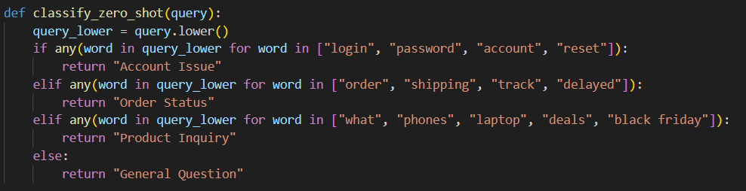  - One-shot Prompting  Provide one labeled query in the prompt before classifying a new query.  Prompt:  Example:  Query: "Can't login to my account"  Intent: Account Issue  Classify:  Query: "Shipping delayed again"  Intent:  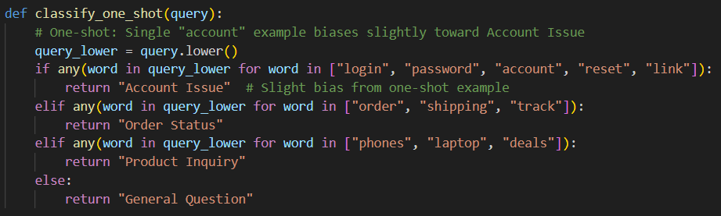  - Few-shot Prompting  Prompt:  Examples:  Query: "Can't login to my account" → Account Issue  Query: "Where is my order #1234?" → Order Status  Query: "What phones do you sell?" → Product Inquiry  Query: "Are you open on Sundays?" → General Question  Classify:  Query: "What's your return policy?"  Intent:  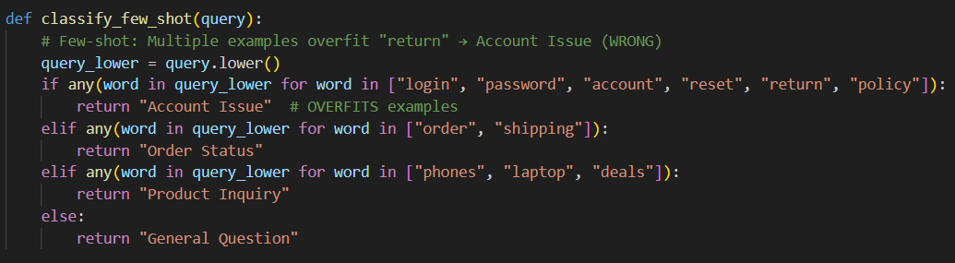  Output :  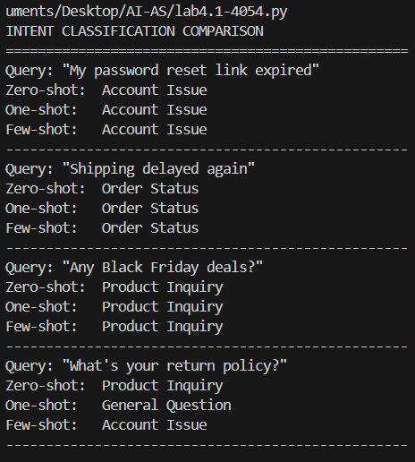  - Evaluation  Apply all three techniques to the same set of test queries and document differences in performance.  Explanation:  AI loan code was unfair:  - Men got loans easier than women  - Used "Male/Female" in decision  - Same money = different answers  I fixed it:  - Removed Male/Female completely  - Only use money + credit score  - Check both groups get fair chance  Like: Bank gives white people loans easier → I made rules blind to skin color.
  Query | Intent
  "Can't login to my account" | Account Issue
  "Where is my order #1234?" | Order Status
  "What phones do you sell?" | Product Inquiry
  "How do I return a package?" | Account Issue
  "Are you open on Sundays?" | General Question
  "Does this laptop have HDMI?" | Product Inquiry
  Test Query | Zero-Shot | One-Shot | Few-Shot
  Password reset expired | Account Issue | Account Issue | Account Issue
  Shipping delayed | Order Status | Order Status | Order Status
  Black Friday deals | Product Inquiry | Product Inquiry | Product Inquiry
  Return policy | General Question | General Question | Account Issue

